# Day 0 - AI ML Internship Log

Date: 08 June 2025

Day: 0

Internship: AI ML Intern

**1. Set Up Activities**

* Set up **Google Colab** and verified it with a sample print command.
* Created a **folder structure** in Google Drive:  
  + AI_ML_Internship_2025/daily_notes
  + AI_ML_Internship_2025/notebooks-All_colab_files
* Installed and practiced with NumPy in Colab.
* Planned to keep a **daily log of activities** and code in organized format.

### **2. Learning Topic: NumPy Basics (Day 0)**

#### **🎥 Watched:**

* Keith Galli YouTube Playlist: NumPy for Beginners
* Referred W3Schools for short theory and examples.

#### **✅ Practiced Topics:**

* Creating arrays (1D, 2D)
* Indexing and slicing
* Appending and inserting elements
* Basic math: addition, subtraction, multiplication
* Trigonometric functions
* Attributes: n.dim, shape, size, itemsize, nbytes,np.array(),np.sin,np.cos etcc

### **3. Key Learnings:**

* np.array() is used for array creation.
* ndim → number of dimensions
* itemsize → memory of a single element (in bytes)
* nbytes → total memory used by the array
* In Colab, only the **last line of the cell auto-displays**; use print() to see multiple outputs.
* Arrays allow fast computation, ideal for ML applications

**4.Self reflection**

I feel good about starting my internship preparation. It was a productive day as I got familiar with Google Colab and verified it using a simple print statement.  
I organized folders in my Google Drive for better management of notes, code, and reports. I began learning the NumPy library, starting with array creation, accessing and modifying elements, and performing basic arithmetic and trigonometric operations.  
Tomorrow, I plan to complete the next part of the NumPy tutorial.

### **📎 5. Resources Used:**

* YouTube: [Complete Python NumPy Tutorial (Creating Arrays, Indexing, Math, Statistics, Reshaping)](https://youtu.be/GB9ByFAIAH4?feature=shared)
* W3Schools NumPy

<https://www.w3schools.com/python/numpy/numpy_intro.asp>

* Colab Notebook: Day_0_numpy_basics.ipynb (saved in notebooks folder)

**6. Code Screenshots**

**1. Simple Print Statement**

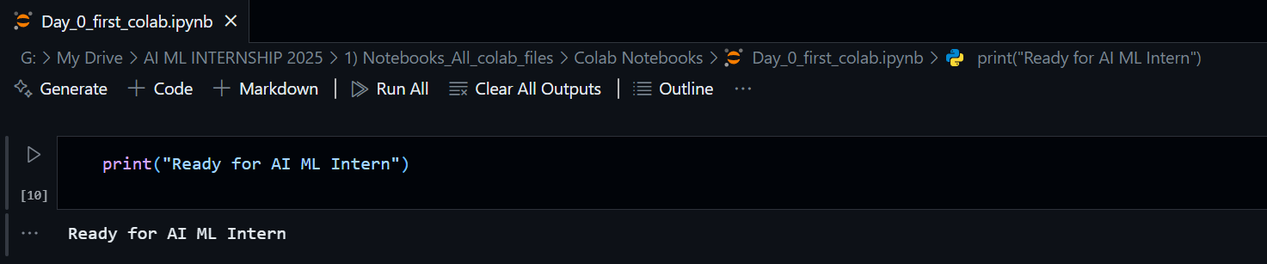

**2. Creation of array , ndim ,itemsize , nbytes**

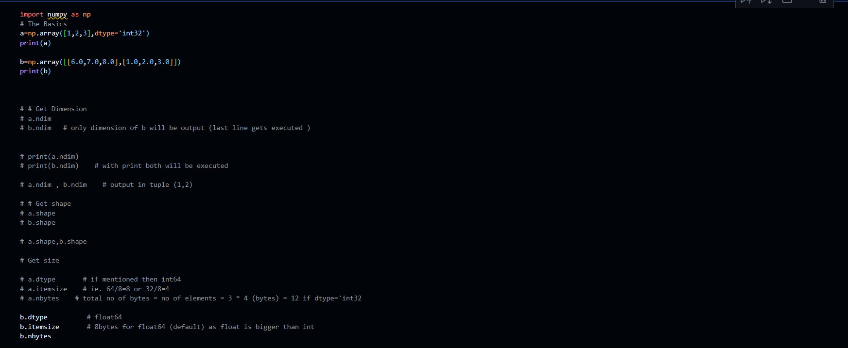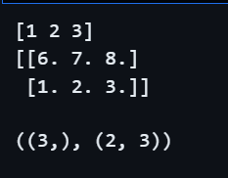

**3. Accessing changing elements rows and columns**

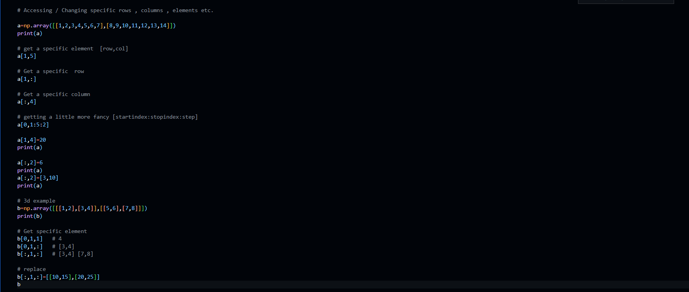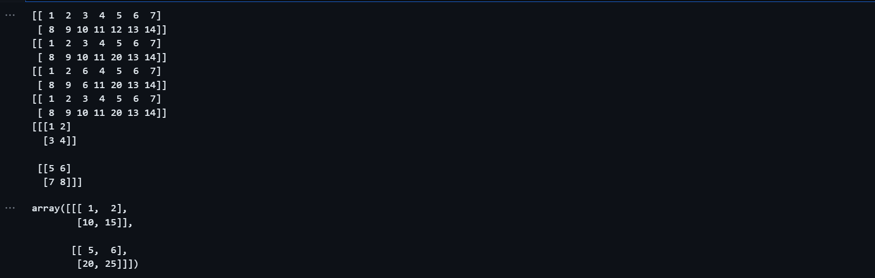

**4.Initializing different types of array**

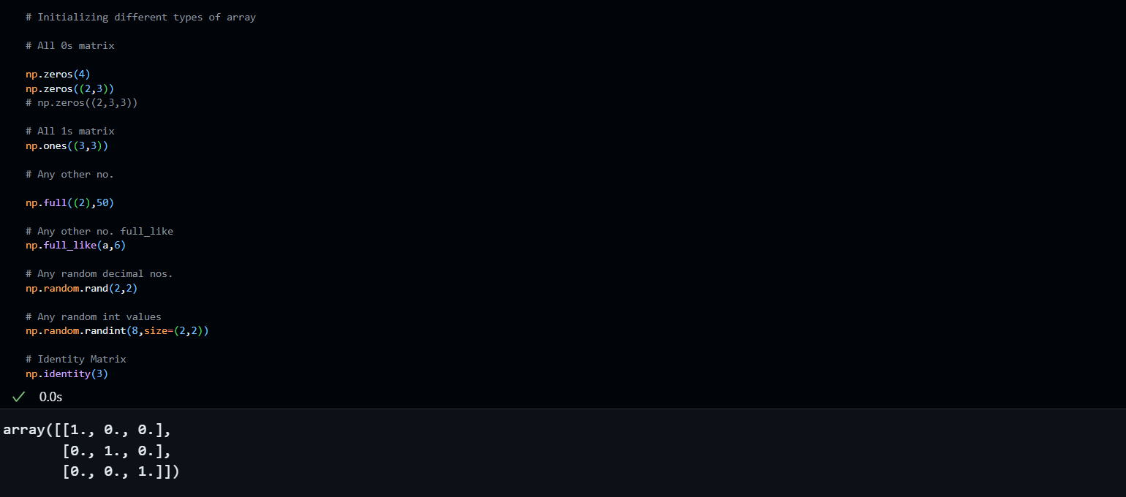

**5.Mathematics(Basic Arithmetic and Trigonometry)**

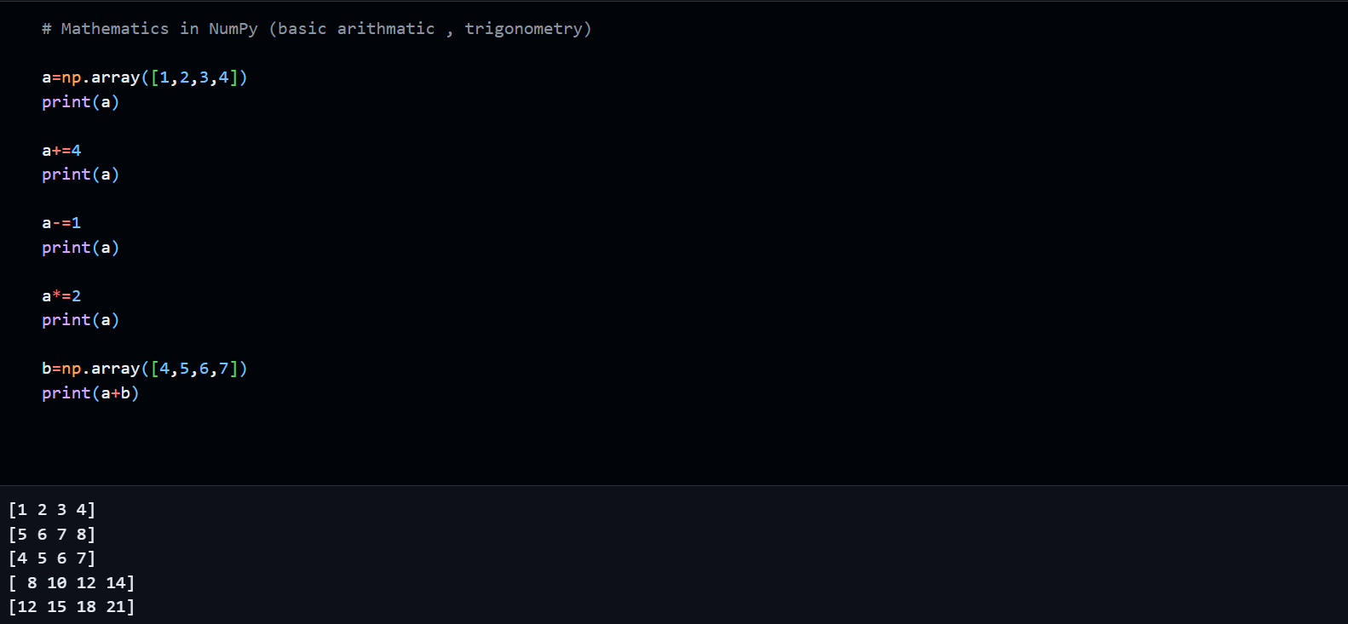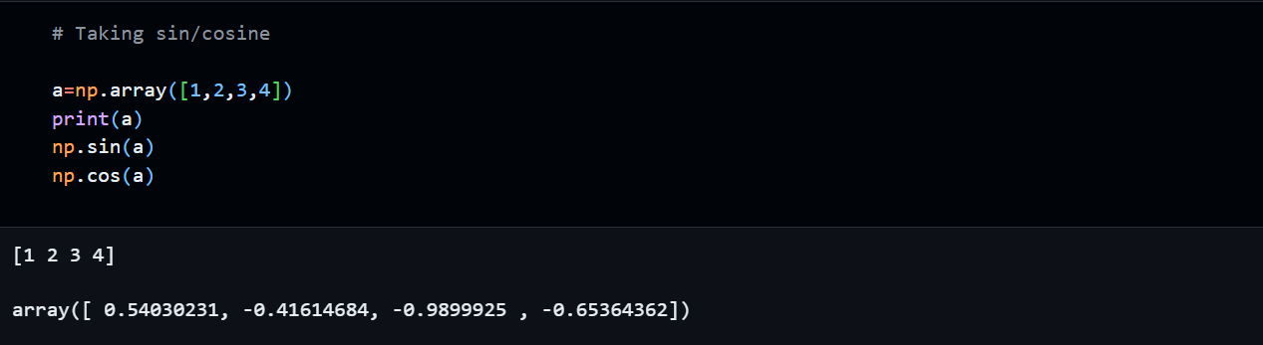

**🔚 7. End of Day Reflection & Next Steps**

**Overall Experience:**

Today’s session helped me become comfortable with the basics of Google Colab and NumPy. I feel more confident in performing array operations and using NumPy attributes efficiently. The organization of resources and notebooks has also made it easier to focus on learning.

**Challenges Faced:**

* Remembering the difference between Python lists and NumPy arrays in terms of operations and speed.
* Displaying multiple outputs in the same Colab cell (resolved using print()).

**Next Steps (Planned for Tomorrow):**

* Complete remaining NumPy topics: reshaping, broadcasting, statistical functions.
* Continue daily log and start handwritten notes or markdown summaries for review.